Enemy Shooting at Player tutorial

This tutorial is going to focus on enemies shooting projectiles towards the player. This will not have the player taking damage, but you can easily add damage code to the projectiles, so it will not be a problem. In addition, this will be for a 3d game so it may not work in a 2d game.

To start you will first need to create two game objects. One will be the enemy, and the second will be the projectile. The enemy can be any object, but the projectile object must be smaller than the enemy. This is so when creating an object, it will not collide with the enemy. After creating those two objects create one empty game object and parent it to the enemy. This will be used as the location which the projectile will be created.

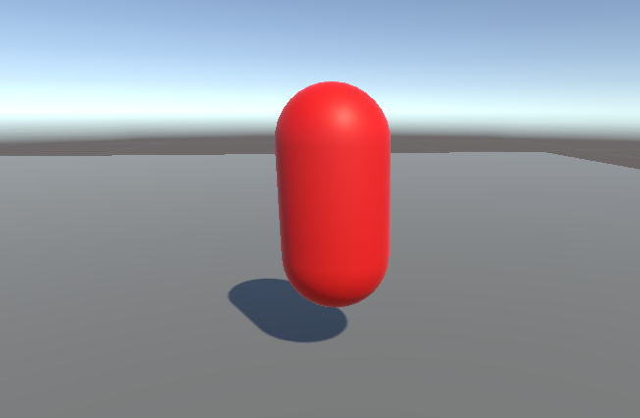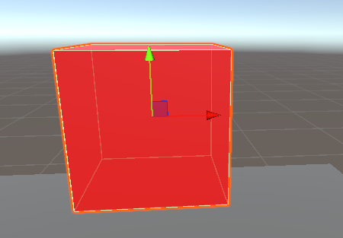



Once all game objects are created you can then make a c# script file and attach it to the enemy. This script will be about what creates and fires the projectile.

But before starting the code, in case you do not have a player yet or are not using a player to test, just create a random object for testing reasons.

First once you enter visual studio add the same number of variables as seen in the image below.

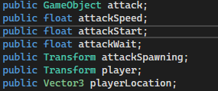

These variables will be used for many things involving the script. The first one is so the code can use the projectile object. Then the second variable is used for the speed of the projectile and can be altered in the inspector as it is a public variable. The next two variables are for how long each projectile will the enemy fire at the player. And the last two variables are transform variables which is how the enemy will know the player location and fire the projectile from the empty object location.

Once all the variables are written you can add this before or after but I'm going to say it now as it would be easier and more organized. In the start function add this line of code as scene in the image. This code will repeat a function which we will soon write. The name of the function can be any name but, in this tutorial, I used “Attacker”. In addition, add these two variables as a scene in the image below. The first will have a smaller number which will start the function right away while the second will have the code repeat each time the number of the variable has passed.



After that create the function which will have the main code for the mechanic.



Then create the two lines of code seen in the image below. The first line is to create the projectile in the position and rotation of the empty game object. While the second line uses the rigidbody in the projectile object to push it towards the front of the empty game object.



So, to have it go to the player just add this line of code in the update function. This will have the enemy always be facing the player by rotating the front which will move the empty game object which should be in front of the enemy at a good distance, so the projectile does not collide with the enemy object.



After making the code of the enemy, make a second c# script and attach it to the projectile object. The code is quite simple as it is mostly used to destroy the projectile once it hits any other object or once its time runs out, which is why we use a variable.

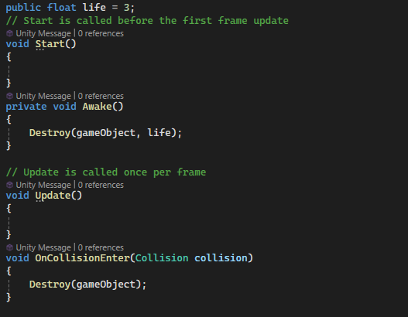

But before testing the mechanic make sure you make the projectile a prefab so it will work.

References:

<https://www.youtube.com/watch?v=EwiUomzehKU>